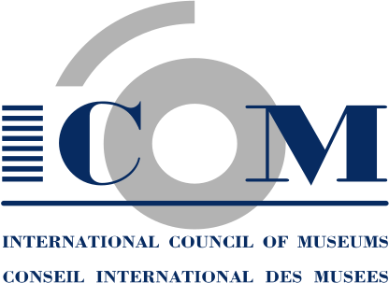  Tel. + 33 (0) 1 47 34 05 00  Fax + 33 (0) 1 43 06 78 62  Email: secretariat@icom.museum  http://icom.museum | INDIVIDUAL MEMBERSHIP APPLICATION FORM  Countries with a National Committee  This form is to be completed (please write LEGIBLY) and  returned to your National Committee

Surname: Mr/Mrs/Ms/Prof/Dr (tick one)

First name: Sex: F/M (tick one) Date of birth:

Position:

Your Institution’s name:

Professional address:

City: | Postal code: |  | Country:
Tel.:  (Please indicate country & area code) |  | Fax:
Email:

Institution’s Web Site:

Mailing address if different from above:

City: | Postal code: |  | Country:
Tel.:  (Please indicate country & area code) |  | Fax:

Category of membership: □ Regular (voting)
□ Associate (voting)
□ Contributor (voting)
□ Retired Professional (voting)*
□ Supporting (non-voting)
* SUBMIT SUPPORTING DOCUMENT

PLEASE NOTE: Membership is annual and runs from January 1 until December 31 of the year in which the subscription is paid. New memberships received after September 30 will become effective as from January 1 of the following year unless otherwise indicated.
➔
Language for correspondence: □English □French
(tick one)

Language for publications: □English □French □Spanish
(tick one)

Please indicate your specialisation (tick maximum 4):

❑ Architecture | ❑ Library/Archives
❑ Audio-visual | ❑ Management/Administration
❑ Cataloging & Inventory | ❑ Marketing & Public Relations
❑ Climate Control | ❑ Planning
❑ Collections Management | ❑ Publications
❑ Computers | ❑ Research
❑ Conservation | ❑ Restoration
❑ Design/Installation | ❑ Security
❑ Education | ❑ Training of Personnel
❑ Exhibition Management | ❑ Visitor Services

Please indicate the type of museum/institution where you are employed:

❑ Agriculture | ❑ Fine Arts | ❑ Money & Banking
❑ Applied Arts | ❑ Historic House | ❑ Musical Instruments
❑ Archaeology | ❑ History | ❑ Natural History
❑ Architecture | ❑ Industrial Heritage | ❑ Open-air
❑ Costume | ❑ Literature | ❑ Photography
❑ Decorative Arts | ❑ Maritime | ❑ Regional/Local
❑ Ecomuseum | ❑ Medicine | ❑ Science & Technology
❑ Education | ❑ Military History | ❑ Sculpture
❑ Ethnology/Ethnography | ❑ Modern & Contemporary Art | ❑ Transport & Communications

I,______________________, declare that I am eligible for membership of the International Council of Museums (ICOM) and wish to become a member of ICOM. I do not engage in dealing (i.e. buying and selling for profit) in the field of cultural property and accept
the Code of Professional Ethics for the museums profession adopted by ICOM.

DATE____________________ SIGNATURE______________________________________

November 2001

